Customer Shopping Behavior Analysis

Executive summary
This report analyzes transaction data (3,900 purchases) to surface actionable insights across customer demographics, product performance, purchase behavior, discounts and subscriptions.
Key findings:
Revenue concentration: A small set of age groups and a minority of customers drive the majority of revenue. Targeted campaigns toward those cohorts will yield higher ROI.
Discount Behavior: Several high revenue purchases occurred even when discounts were applied, indicating price-sensitive high spenders and cross-sell opportunities
Subscription: Subscribers spend more on average and contribute a disproportionately high share of total revenue; subscription growth should be prioritized.
Product performance: Top-rated products align closely with best-selling products in several categories, suggesting product quality is strong driver of repeat purchases.
Shipping: Express shipping correlates with higher average order values, presenting an opportunity to promote faster shipping as a premium upsell.

This report gives detailed segment-level findings, recommended KPI’s and next steps for product, pricing, and marketing teams.

Data and Pre-processing summary
- Rows 3900
- Columns 18
Key dimensions: customer demographics (age, gender, location, subscription_status), purchase details(product, category, purchase_amount, season, size, color), behavior indicators (discount_applied, promo_code_used, previous_purchases, purchase_frequency_days, review_rating, shipping_type)
Missing data: 37 missing values in review_rating column.

Data cleaning steps peformed
- Loaded data into pandas (df.info(), df.describe()) and standardized column names to snake_case.
- Imputed missing review_rating using the median rating per product category.
- Dropped promo_code_used after finding strong redundancy with discount_applied.
- Created engineered fields:
Age_group (binned ages into cohorts such as Young Adult, Adult, Middle Age, and Senior)
Purchase_frequency_days (days between purchases, derived from timestamps)
Customer_segment (New, Returning, Loyal) based on purchase count threshold.
- Loaded cleaned dataframe into MySQL for SQL-based analysis and created Power BI dashboard for visualization.

Data Analysis using SQL

We performed structured analysis in mysql to answer key business questions:
- Revenue by gender - compared total purchase amounts between genders.
The Males contribute a higher share of orders and revenue resulting to a high average order value(AOV) which shows the differences in purchases size.
This segment(Male) should be prioritized for lookalike marketing and product assortment.
Business Actions:
Tailor campaigns and promotions to the Males segment while designing acquisition strategies for Female segment.
Consider merchandising and product bundles that increase AOV for the Female gender
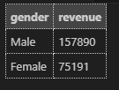

- High-spending discount users - identified customers who used discounts but still spent above the average purchase amount.
Results:
Existence of discount-using yet high-spending customers signals that discounts can pull larger basket sizes or attract premium buyers during promotions.
These customers are high-value and responsive to offers making them prime candidates for targeted promo stacks or loyalty incentives.
Business Actions:
Create exclusive, tiered discounts for high-value shoppers that encourage frequency but protect margin (e.g., bundle discounts, threshold-based free shipping).
Use personalized offers rather than blanket discounts to preserve margin.

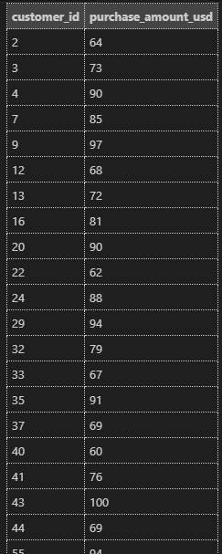

- Top 5 products by rating - found products with highest average review ratings
Results:
These top-rated products should be cross-referenced with sales volume to see if high rating translates to high revenue.
If they have low sakes, they are opportunities for better placement/promotion.
Business Action:
Promote these products in marketing channels and on product pages; use ratings in ad copy.
Consider inventory prioritization for these items and cross-sell with faster SKU’s
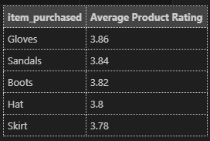

- Shipping type comparison - compared average purchase amounts between standard and express shipping
Results:
Express shipping customers have higher average order values compared to standard shipping customers.
Express shipping often indicates urgency or higher willingness to pay for convenience.
Busines Action:
Position express shipping as a premium offering; offer value-add bundles or limited-time faster-ship incentives for higher AOV
Test price elasticity of express shipping fees and consider free-express thresholds (e.g.,free express for orders above a certain value).
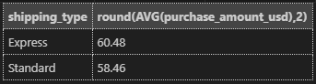
- Subscribers vs. Non-subscribers - compared average spend and total revenue across subscription status.
Results:
The non-subscribers show slightly high average spend.
Subscription correlate with loyalty and increased lifetime value.
Business Action:
Promote subscription benefits more aggressively; test trials, referral bonuses, and retention perks.
Personalize subscription communications to reduce churn and increase subscription lifetime.
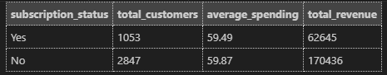
- Discount-dependent products - identified 5 products with the highest percentage of discounted purchases.
Results:
Some products mostly sell when discounted, these are discount-dependant and may have limited full-price demand.
Business Action:
Re-evaluate pricing, positioning, and margin strategy for discount-dependent SKUs.
Use bundling or product enhancements to increase perceived value and reduce dependence on discounts.
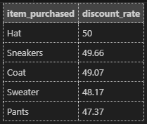
- Customer segmentation - classified customers into new, returning, and loyal segments based on purchase history.
Results:
Loyal customers (10+ purchases) are the majority of customers resulting to a large share of revenue. However, returning customers are the main source of growth potential, converting them to loyal through targeted programs is cost-effective
Business Actions:
Implement lifecycle marketing: welcome series for new cusomes, win-back for lapsing customers, VIP perks for loyal customers.
Measure conversion rates between segments (new to returning, returning to loyal) as KPIs.
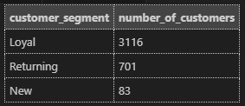
- Top 3 products per category - listed the most purchased products within each category.
Results:
Top products vary by category; many categories display a clear long-tail where a few SKUs carry most volume.
Business Action:
Optimize inventory and bestseller placement per category; run category-specific promotions highlighting top SKUs.
Consider private-label or exclusive variants for top categories.
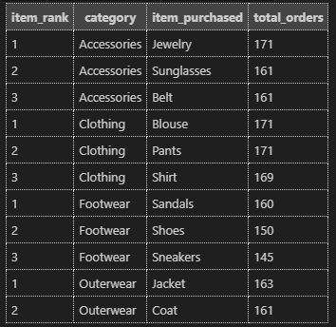
- Repeat buyers and subscription - checked whether customers with >= 5 purchases are more likely to subscribe.
Results:
Loyal customers are more likely to be subscribes, subscription drives repeat purchases or vice versa.
Business Action:
Bundle subscription sign-up at points of high satisfaction (post-purchase, post-delivery) to increase conversion.
Provide incentive for loyal customers to refer friends to subscription plans.
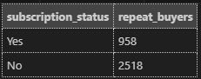
- Revenue by age group - calculated total revenue contribution of each age group.
Results:
The Young Adults and the Middle -age age groups contribute the largest share of revenue.
Business Action:
Tailor campaigns and promotions to the young adults and middle-aged while designing acquisition strategies for adult and senior even though their performance isn't that bad.

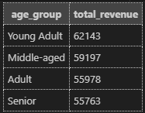

Dashboard in power BI

